|  |  |
| --- | --- |
|  | SR UNIVERSITY  Campus Warangal |
| Program: II - B.Tech (CS& AI) |
| Professor(a): Dr. Venkataramana Veeramsetty, Professor |
| Department: Computer Science and AI Semester: I |
| AI Assisted Coding - Lab Test 1 - Set B |
| Instructions:   1. Use AI Tools like VScode+Github Copilot and Cursor AI for code generation 2. This Assignment will be evaluated for 15 Marks (10 Marks for Tasks and 5 Marks for viva based on regular lab activities) 3. Students need to submit assignment through canvas before due date 4. Students who are absent for lab will receive 0 Marks | |

1. Create a Python function that converts an amount from one currency to another using exchange rates stored in a dictionary. Use GitHub Copilot along with VS Code. Use Few shot prompting.

# Example 1: Function to calculate the area of a rectangle

Def calculate_area(length, width):

“””

Calculate the area of a rectangle.

Args:

Length (float): The length of the rectangle.

Width (float): The width of the rectangle.

Returns:

Float: The area of the rectangle.

“””

Return length * width

# Example 2: Function to find the largest number in a list

Def find_largest(numbers):

“””

Find the largest number in a list.

Args:

Numbers (list): A list of numbers.

Returns:

Float: The largest number in the list.

“””

Return max(numbers)

# Task: Create a function that converts an amount from one currency to another.

# Use exchange rates stored in a dictionary.

# Function name: convert_currency

# Arguments: amount (float), from_currency (str), to_currency (str), rates (dict)

# Return: converted amount (float)

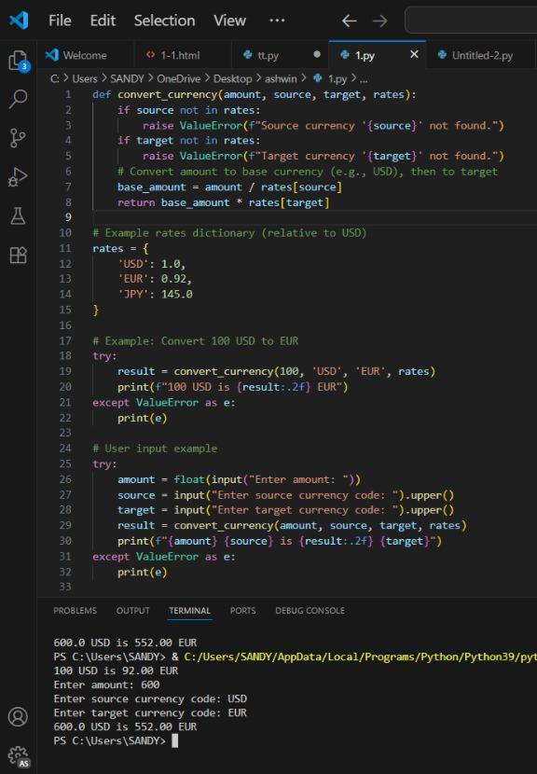

2.Write a Python program to extract all email addresses from a block of text using regular expressions. GitHub Copilot along with VS Code. Use zero shot prompting.

Prompt: create a Python program to extract all email addresses from a block of text using regular expressions by taking input randomly and generate the random email address

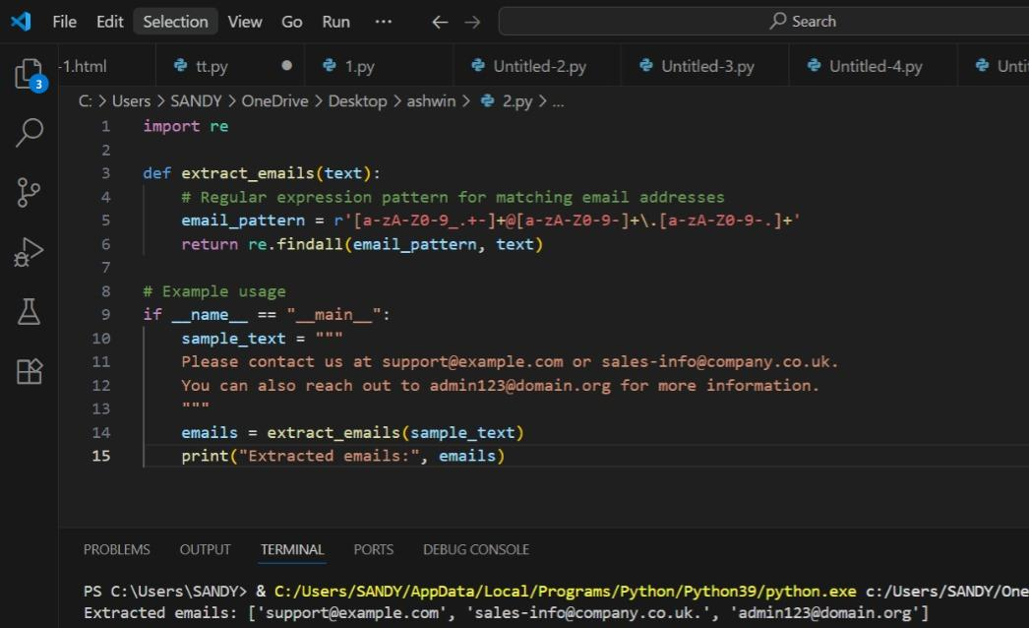

3.Given a list of movies with their genres, Write a Python function that recommends movies based on a user’s preferred genre. Use the Cursor AI tool. Use few shot prompting.

Pormpt:Write a Python function that suggests movies according to a user’s favorite genre.

First, create a list containing movie titles along with their respective genres.

Take the user’s preferred genre as input from the console.

From the list, recommend any three movies that match the chosen genre.  
Ex  
1. Enter your favourite genre : action  
These are movies available:

Die hard

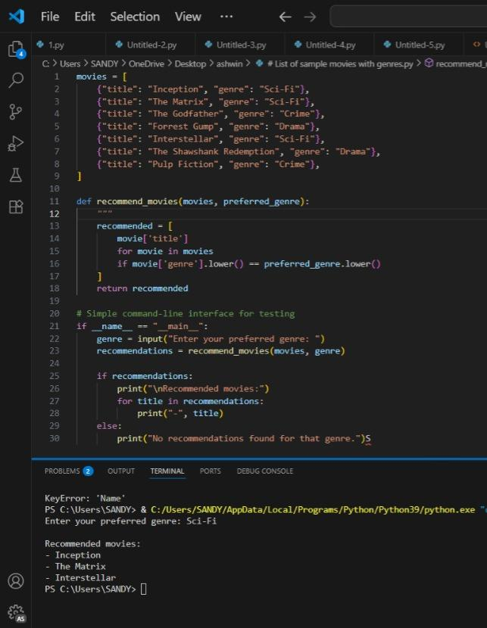

1. Write Python code that reads a CSV file containing student names and marks in 3 subjects. Calculate the total and average marks for each student. Use the Cursor AI tool.

Prompt: Create a Python program to read a CSV file containing student names and their marks in Maths, Physics, and Chemistry.

Calculate the total and average marks for each student.

Ask the user to provide the CSV file path through console input.

Then prompt the user to enter a student’s name.

Also ask whether they want to see the student’s total marks or average marks.

Display the requested result accordingly.

Ensure proper handling for cases where the student name is not found in the file.

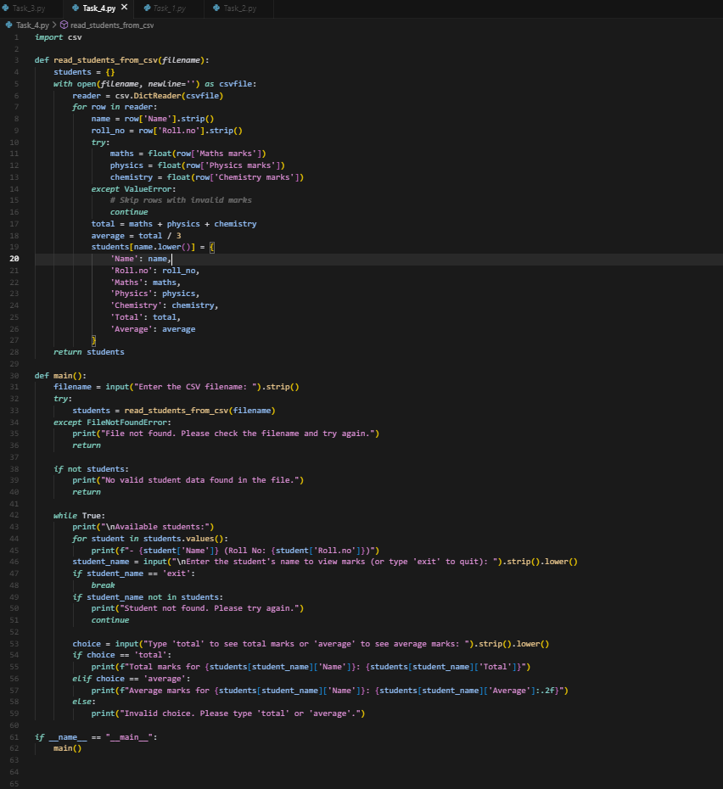

Date: 2025-08-14

©Dr. Venkataramana Veeramsetty, Professor Pag. 1 de 1